Report on the National Scientific Conference on Multidisciplinary Research (NSCMR 2022)
Venue: Government Science College Gadchiroli
Date: 07th and 08th April 2022

The National Scientific Conference on Multidisciplinary Research (NSCMR 2022) was organized by the Government Science College Gadchiroli in association with Indian Science Congress Amaravati Chapter. The conference was held in Government Science College, Gadchiroli, Maharashtra on 7th and 8th April, 2022.
Gadchiroli is situated in the south-eastern part of Maharashtra state. Gadchiroli district shares its boundaries with Chattisgad and Telangana states. The district is categorized as tribal and undeveloped, with farming as the main occupation. Forests cover is more than 79.36% of the hilly geographical area of the district. Government Science College Gadchiroli is a degree college in Gadchiroli district Maharashtra, India. The College is established on 11/09/1987 and run by Government of Maharashtra, Department of Higher and Technical Education, Mumbai (M.S.). It is the only Government College in this remote/tribal place of Gadchiroli running undergraduate and post graduate courses in sciences. The college has been under the jurisdiction of the Gondawana University, Gadchiroli. The college offers bachelor degree courses (BSC), post graduate courses. College is approved research center in the Botany, Chemistry and Zoology subjects.
The focal theme of conference was “Sustainable Development with Women Empowerment” and Physical Science, Chemical Science, Life Science, Sports science, Agriculture and forestry Science, Computer Science, Mathematics, Library Science were included in subthemes. The conference provided a platform for young researchers, scientists, academicians and students of Science faculty from different parts of India to present their original research work in the form of poster and oral presentations.
The conference was in inaugurated by Hon’able Dr. (Mrs.) Vijay Laxmi Saxena, General President, Indian Science Congress Association, Kolkata. The inaugural function was graced by Dr. Ashok Kumar Saxena, Former, General President, Indian Science Congress Association, Kolkata, Dr. Sheo Satya Prakash, Treasurer, Indian Science Congress Association, Kolkata, Dr. Nibedita Chakrabarti, Elected member of executive committee, Indian Science Congress Association, Kolkata, Dr. Manoj Kumar Chakrabarti, former General Presedent, Indian Science Congress Association, Kolkata. Dr. Mahesh P. Chikhale, Executive Committee Member, Amravati Chapter, ISCA, Dr. Gajanan B. Santape, Rajashree Science College, Chandur Railway, Amaravati, Dr. R. G. Munghate, Management Council Member, Gondwana University, Gadchiroli and Principal, Shri. Govindrao Munghate Arts and Science College Kurkheda, Gadchiroli, Dr. N. S. Kokode, Principal, Nevjabai Hitkarini College,Bramhapuri, Chandrapur, Dr. Rajesh Dahegaonkar, Dr. Ambedkar College of Arts, Commerce and Science, Chandrapur were present as a guest of honour for inauguration session. Dr. Hemlata Chaudhari-Wankhede, Convener, Principal, Government Science College, Gadchiroli, Dr. Atul K. Bodkhe, Amravati Chapter Convener, ISCA, Abdul Chaudhari Organizing secretary and Amar Kuril Co-organizing secretary preceded the inauguration ceremony. Dr. (Mrs.) Vijay Laxmi Saxena, Dr. Nibedita Chakrabarti and Dr. Manoj Kumar Chakrabarti shared their experience and knowledge with participants. The dignitaries also stressed on collaborative research and also encouraged the participants to carry out multi-disciplinary research.
A keynote address was delivered by Prof. Devesh Walia, Professor, Environmental Studies Department, North- Eastern Hill University, Shilong. Prof. Walia shared his treasure of knowledge with focus on sustainable development with women empowerment. Dr. Lal Singh Senior Scientist CSIR-National Environmental Engineering Research Institute (CSIR-NEERI), Nehru Marg, Nagpur, Maharashtra presented his exciting work on eco-rejuvenation of wasteland for socioeconomic development in rural areas. The excellent presentation of Dr. Lal Singh was followed by another motivating lecture on organic vs. conventional cultivation of anti-diabetic medicinal plants by Prof. Prakash R. Itankar from Department of Pharmaceutical Sciences, Pharmacognosy and Phytochemistry Division, Rashtrasant Tukadoji Maharaj Nagpur University, Nagpur. Dr. Itankar shared his experience in networking with different stakeholder of medicinal plant breeders and vaidus. The session was chaired by Prof. Suresh Zade, former Head and Professor, Post Graduate Teaching Department of Zoology, R.T.M. Nagpur University, Nagpur.
After invited lectures, technical session of oral presentation and poster presentation was conducted by Dr. Rajesh Dahegaonkar, Dr. Ambedkar College of Arts, Commerce and Science, Chandrapur. In first technical session, 15 participants presented their research work in form of oral presentation. After oral presentations the poster presentation session was conducted. After poster presentation proceedings of day 1, 07 April 2022 was concluded at 06.00 pm. The next invited lecture session was started on day 2, 08 April 2022 at 10.00 am.
In second session of invited lectures, Dr. Mandar Paingankar of Government Science College Gadchiroli presented his work on deciphering the arginine and lysine protein methylation pattern in Drosophila cells in response to Nitric oxide stress. After lecture on protein methylation, Santosh Ashtaputrey from Government Science College Gadchiroli presented his work on adsorption kinetics and batch study of toxic heavy metal Ions removal using bio waste orange peel activated carbon from synthetic waste water. After invited lectures, 09 participants presented their research work in oral presentation session. Three participants from oral presentation and two participants from poster presentation were awarded with best presentation award.
Dr. Hemlata Chaudhari–Wankhede was chief guest of the valedictory function and best presentation awards given in valedictory function. In concluding remark Dr. Hemlata Chaudhari–Wankhede discussed about the success of conference and thanked all the dignitaries, researcher, participants, volunteers and sponsors for their help during the conference. After vote of thanks from organizing committee the two days National Scientific Conference on Multidisciplianary Science was concluded.

Glimpse of NSCMR 2022

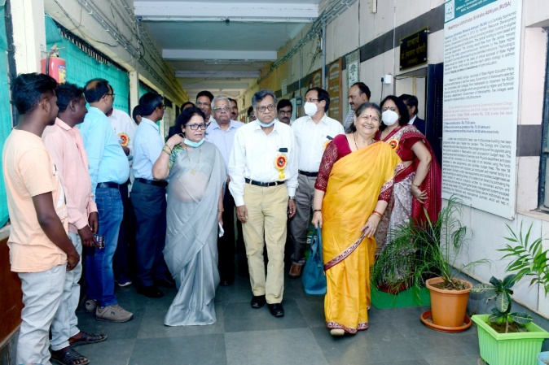 | 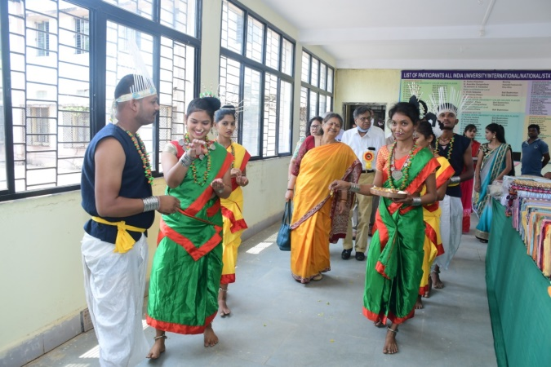
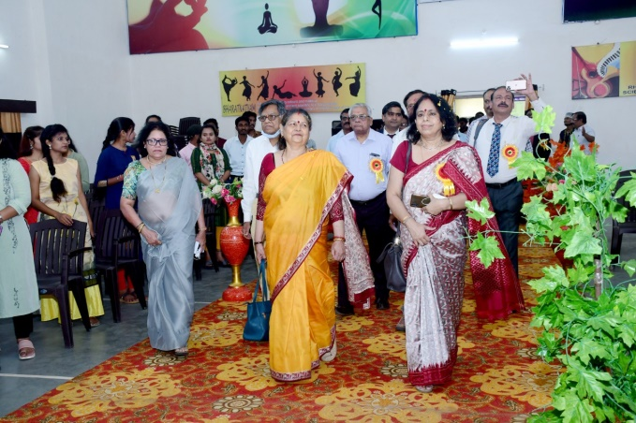 | 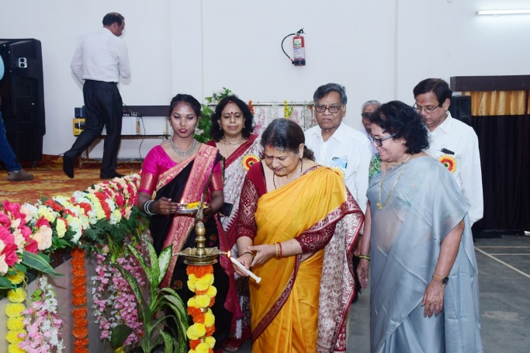
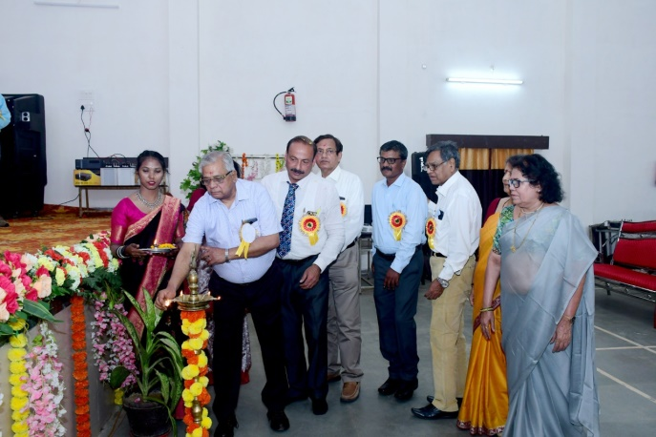 | 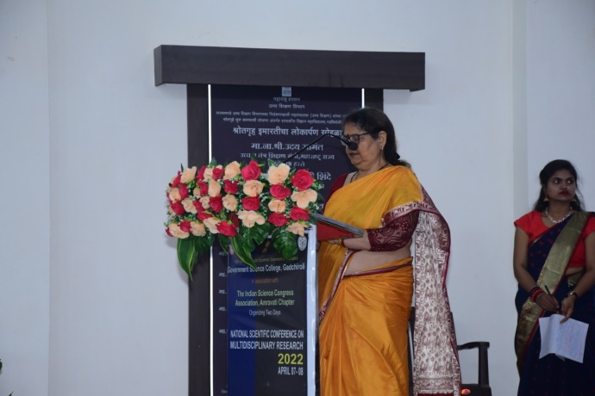

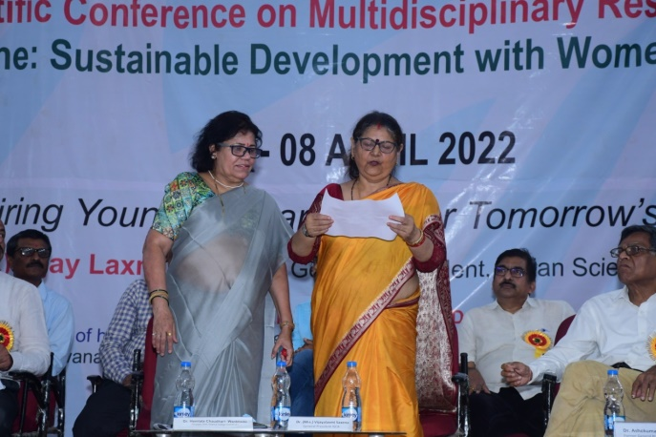 | 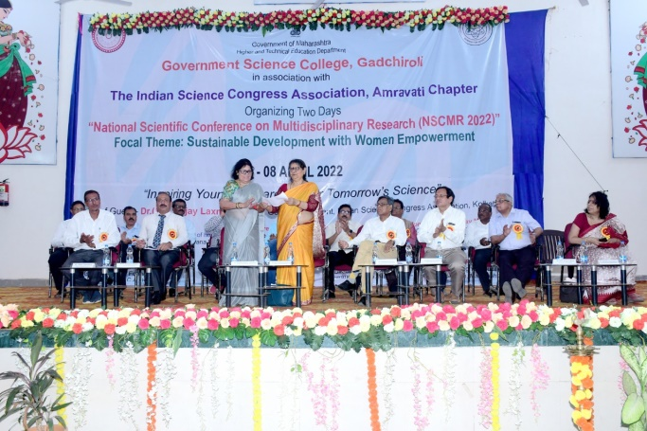
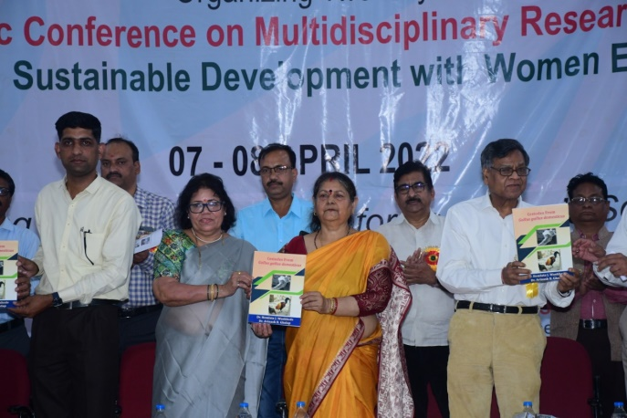 | 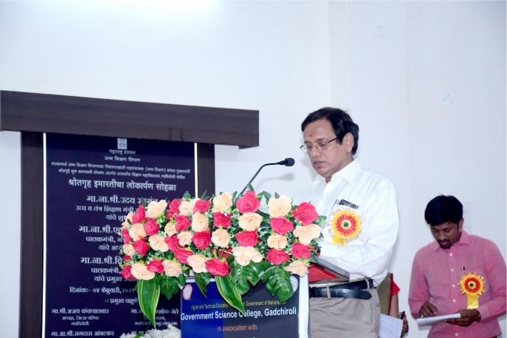
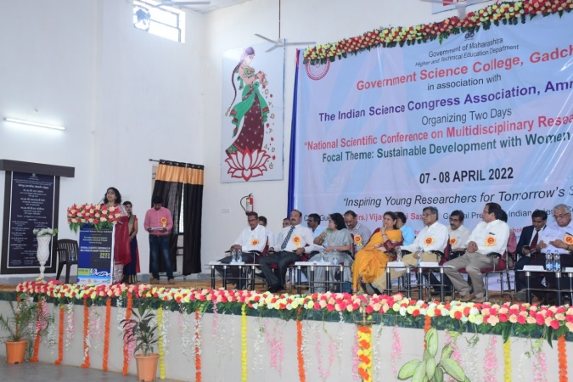 | 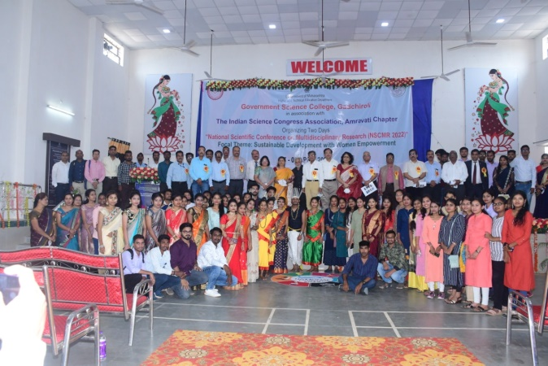
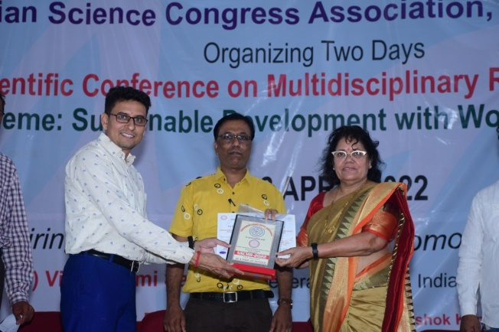 | 